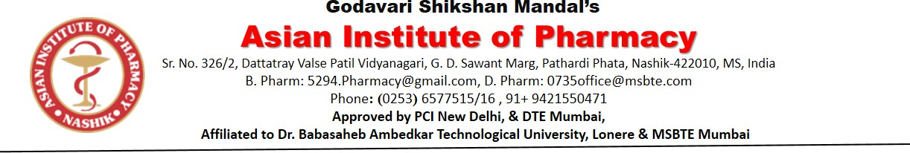

Event Report

Title of the event | 79th Independence Day 2025
Organized Date | 15 August 2025
Name of the coordinator | Ms. Ankita K. Chaudhari  Ms.Simran Rawale
Name of Participants | Students and Faculty members
Objective of program | - The objective of the Independence Day Program is to commemorate the historic day when our nation gained freedom from colonial rule and to honor the countless sacrifices made by our freedom fighters. The program aims to instill a sense of patriotism, unity, and pride among citizens, especially the younger generation. Through various cultural performances, speeches, and activities, the program seeks to educate people about the importance of independence, promote national values, and inspire everyone to contribute positively to the progress and unity of the country.
Outcomes of the program | - Commemorate Freedom: To honor the country’s liberation from colonial rule and celebrate the achievement of sovereignty.  - Remember the Sacrifices: To pay tribute to the freedom fighters and leaders who gave their lives and efforts for the nation’s independence.  - Promote Patriotism: To inspire love, respect, and loyalty towards the country among all citizens.  - Encourage National Unity: To bring people together in celebration, regardless of region, religion, or background, reinforcing the spirit of unity in diversity.  - Educate and Inspire: To make the younger generation aware of the nation’s history and their role in shaping its future.

Program Details:

The 79th Independence Day of India was celebrated with great enthusiasm and patriotic fervor at Asian Institute Of Pharmacy, Nashik.on 15th August 2025. The entire premises were decorated with national flags, tricolor balloons, and posters reflecting the spirit of freedom. The program began at 7.30AM with the hoisting of the national flag by the Chief Guest, Mr. Bakerav Baste Sir, Mr. Ashok Sawant Sir, Dr. W. N. Bhende Sir & Dr. K.R. Dandagvhal Sir. This was followed by speeches highlighting the significance of the day, remembering the sacrifices of our freedom fighters, and emphasizing the importance of unity and responsibility in building a better nation. Cultural performances including patriotic songs, dances, skits, and poetry recitations by students added color and vibrancy to the event. The chief guest delivered an inspiring address, urging the youth to uphold the values of freedom, integrity, and service to the nation. Prizes and certificates were distributed to students who excelled in competitions held as part of the celebration. The program concluded with a vote of thanks and a pledge to contribute towards the nation’s progress with honesty and dedication. Overall, the event was a great success, leaving everyone with a renewed sense of patriotism and national pride.

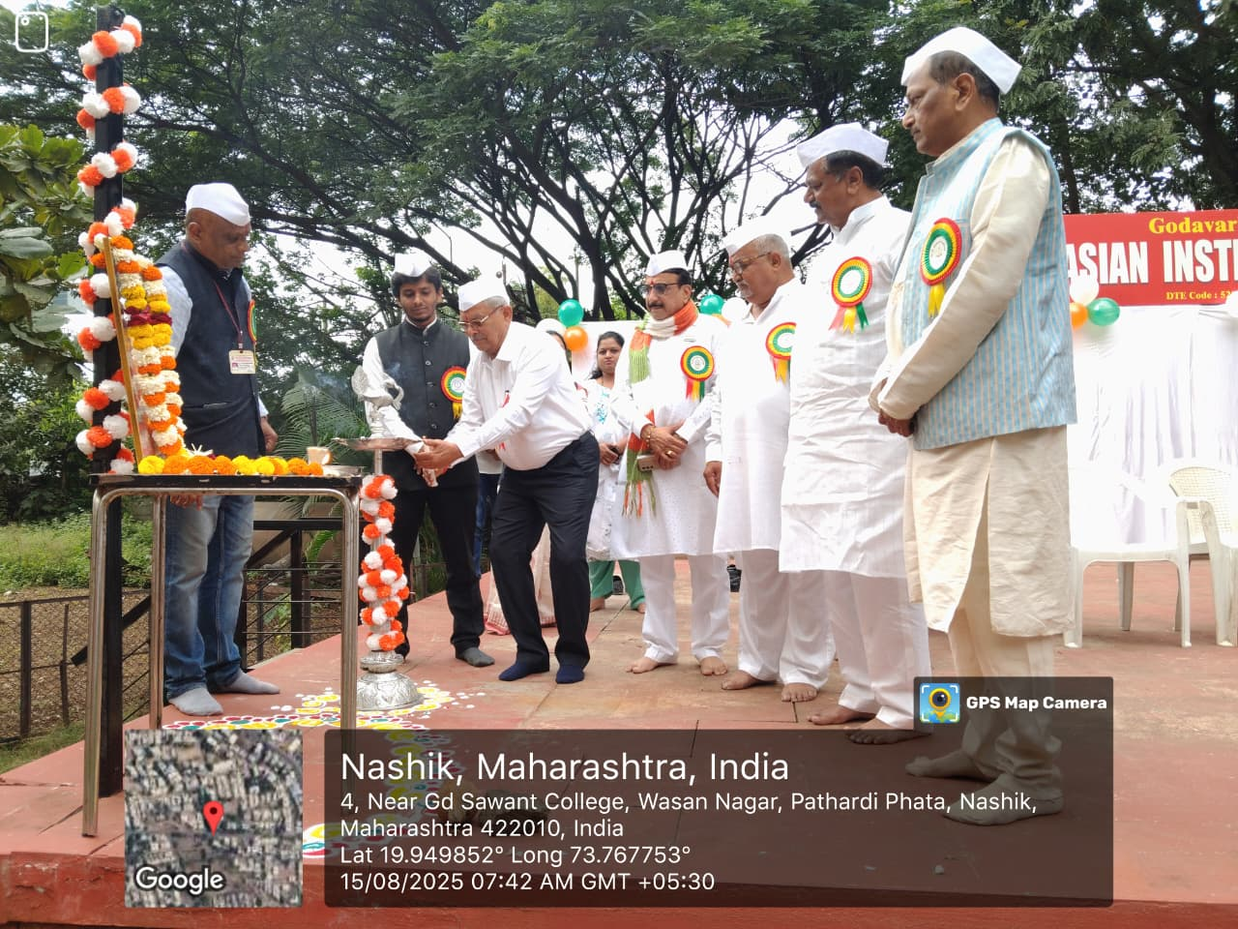

Lamp Lighting Ceremony in Honor of Bharat Mata

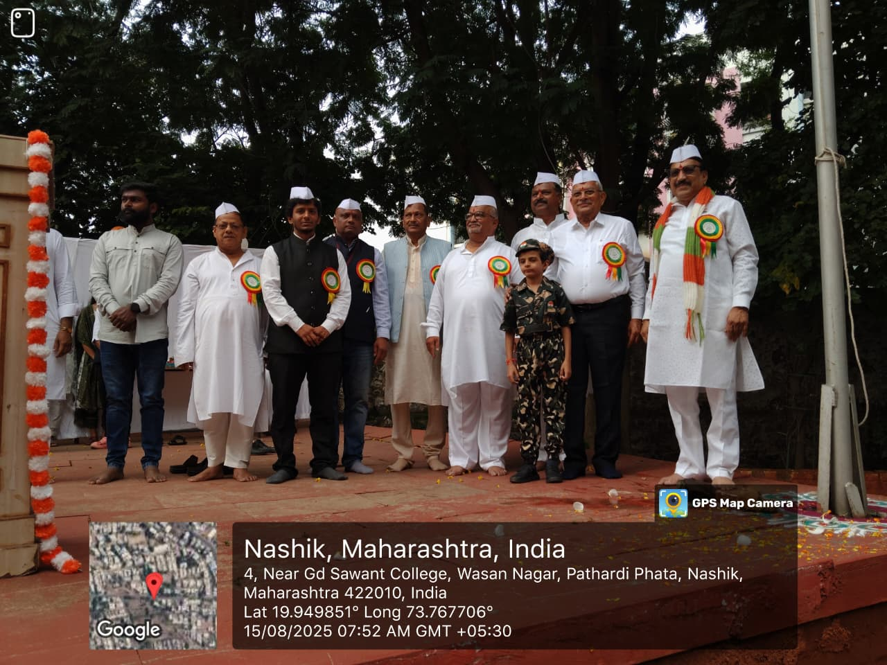

Honorable Chief Guest

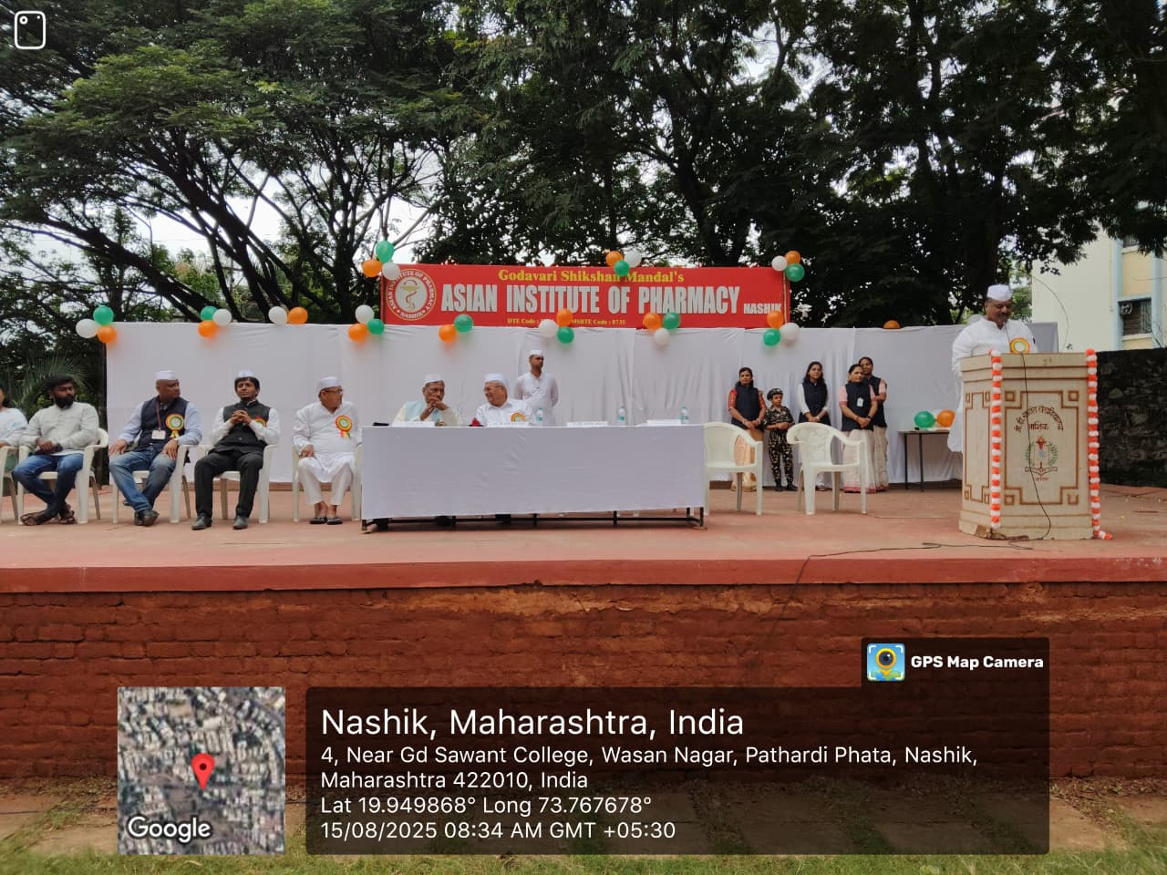

Valuable Speech Mr. Ashok Sawant Sir Sharing Words of Wisdom

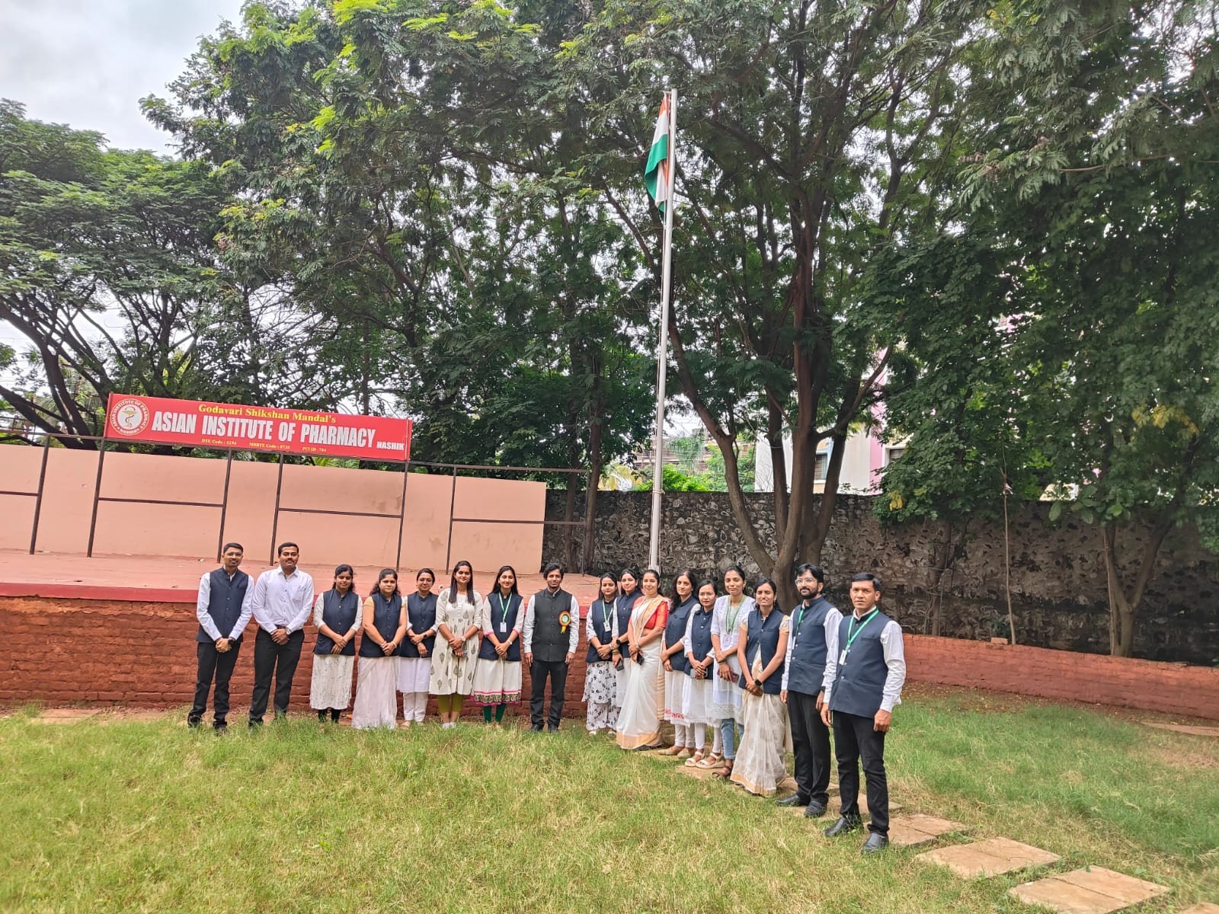
Dr. K. R. Dandagvhal and Dedicated Staff Members

Event Co- ordinator Principal

