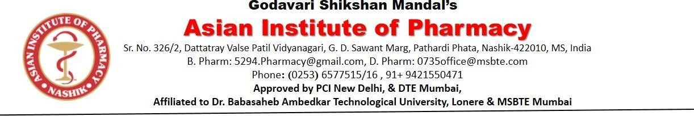

Event Report

Title of the event | Dahi Handi Celebration
Organized Date | 16 August 2025
Name of the coordinator | Ms.Neha Sanap Ms.Ankita Chaudhari
Name of Participants | Students and Faculty members
Objective of program | The objective of the Dahi Handi celebration in our college is to preserve cultural traditions, promote teamwork and unity among students, encourage active participation in cultural activities, and create a joyful atmosphere that blends festivity with values of cooperation and harmony.
Outcomes of the program | - Cultural Awareness: Students gained knowledge and appreciation of Indian traditions and the significance of Janmashtami.  - Teamwork & Unity: The event strengthened team spirit, cooperation, and coordination among participants.  - Student Engagement: High participation boosted enthusiasm, confidence, and involvement in extracurricular activities\  - Skill Development: Students enhanced their leadership, organizational, and creative skills through active roles in the program..

Program details:

Dahi Handi was celebrated with great enthusiasm and festive spirit on 16th August 2025 at the Asian Institute of Pharmacy, Nashik. To mark the occasion of Janmashtami. The event beautifully showcased the cultural tradition of breaking the handi, a ritual that symbolizes teamwork, unity, and collective joy. The program began with a brief introduction about the significance of Janmashtami, followed by traditional rituals and vibrant cultural performances by the students. The highlight of the event was the human pyramid formed by students to break the handi, conducted under safe and guided supervision. The entire campus was filled with energy, cheers, and an air of celebration as students, faculty, and staff came together to enjoy the festivities. Dr. W. N. Bhende Sir & Principal Dr. K. R. Dandagvhal addressed the gathering and appreciated the students’ enthusiastic participation. He emphasized the importance of teamwork, discipline, and harmony, values strongly reflected in the Dahi Handi tradition. The event concluded with a heartfelt vote of thanks and the singing of the national anthem. It was not just a celebration of a festival, but also a reflection of unity, cooperation, and cultural awareness, leaving behind cherished memories for all attendees.

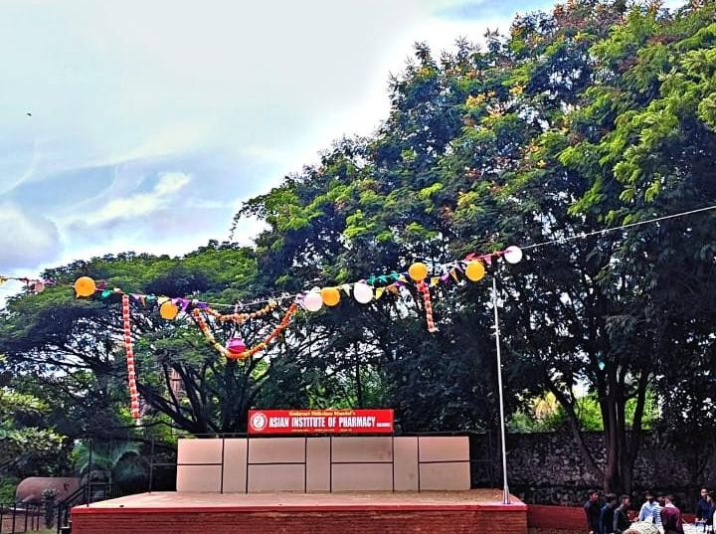

Dahi Handi Decoration Celebration
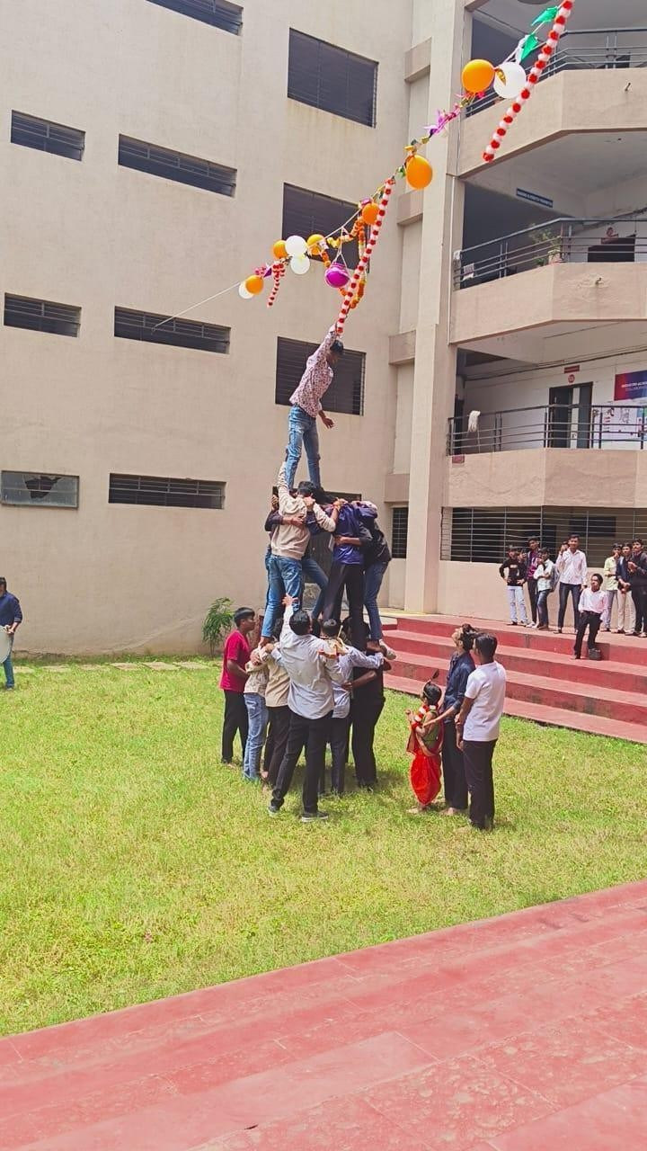

Dahi Handi Celebration

Event Co- ordinator Principal

