Ms.Harshali.J.Ahire

Publication No. 1 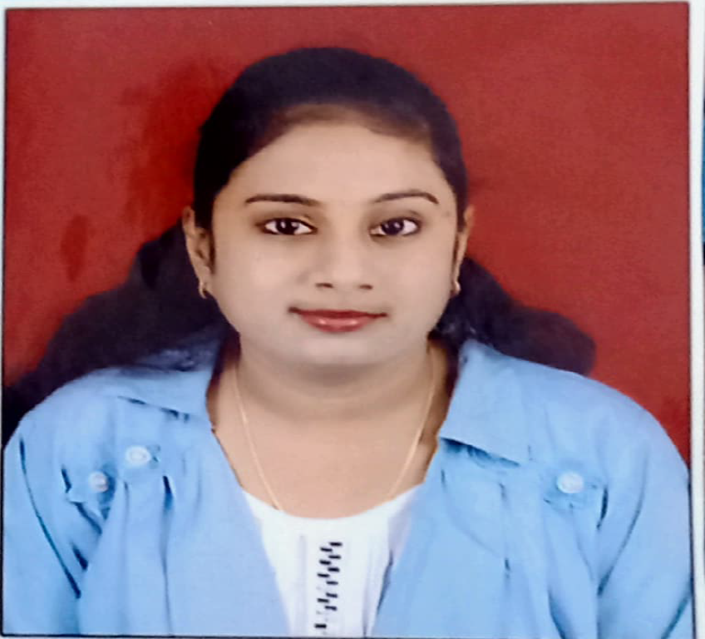
Author Name: Ms. H . J. Ahire
Publication Name: New Technology for Ayurveda Formulation .
IJPSN - International Journal of Pharmaceutical Sciences and Nanotechnology_ [Review Article]
Publication Date: November - December 2024
Institute Name: Shree Balaji Sikshan Prasarak Mandal B. Pharmacy college Ambajogai.

Publication No. 2
Author Name: Ms. H . J. Ahire
Publication Name: Preparation and Evaluation of Silver Nanoparticles Using Praval Pishti for Wound Healing .
IJFANS- International Journal of Food and Nutritional Sciences [Research Article]
Publication Date: January 2025
Institute Name: Shree Balaji Sikshan Prasarak Mandal B. Pharmacy college Ambajogai.

Research Summary-
International Conferences: 2
National Conferences: 1
Total Publications: 2
Online Certification Courses: 2
FDP / Workshops Attended: 1

Additional Details :
Designation: Assistant Professor
Dept of Pharmaceutics - M. Pharm
Google Scholar
https://doi.org/10.37285/ijpsn.2024.17.6.9
Teaching Experience : .5 Months at Asian Institute of Pharmacy.

