Ms .Ankita.K.Chaudhari 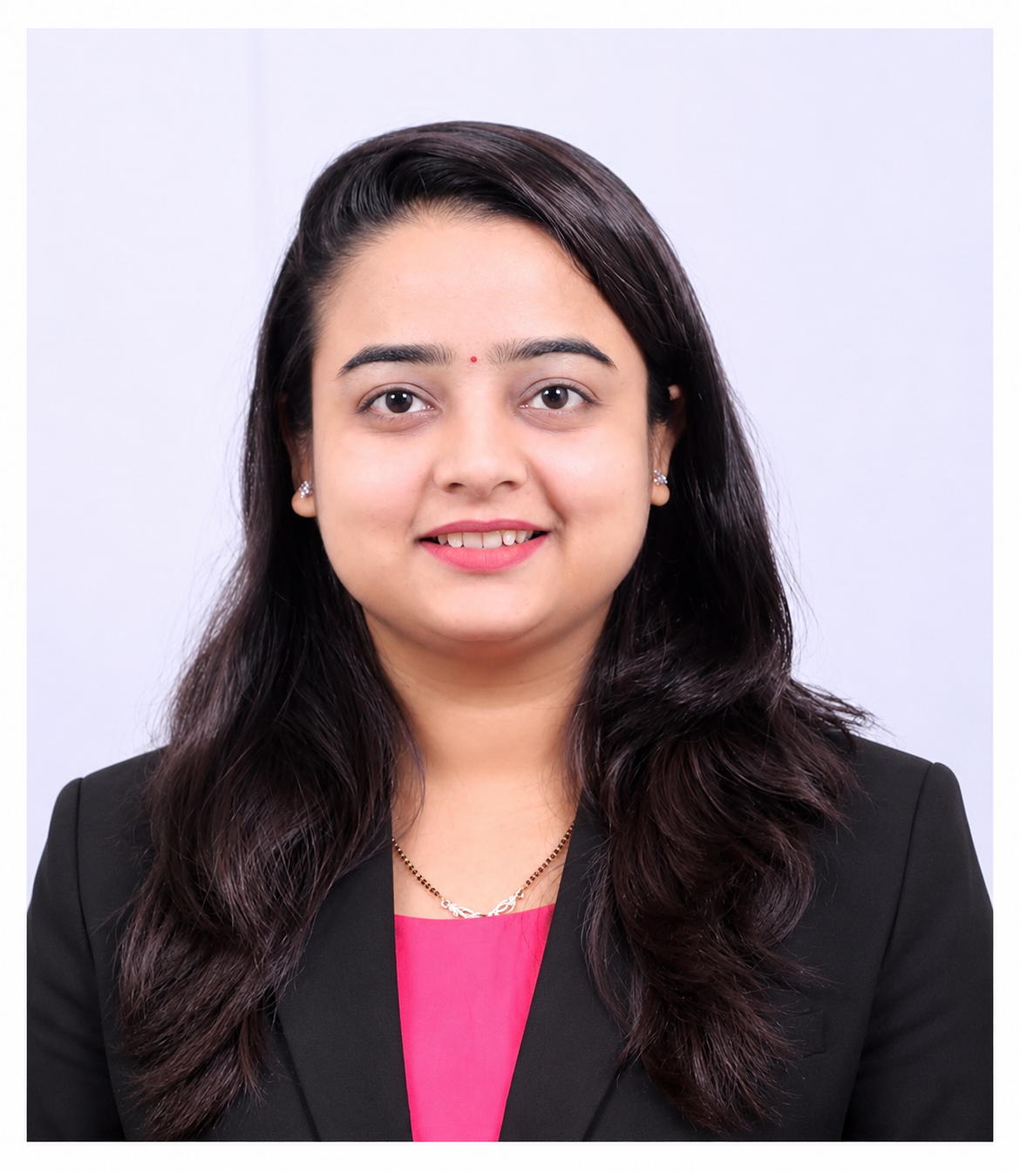

Publication No. 1

Author Name: Ms. Ankita.K.Chaudhari

Publication Name: An updated overview on mucoadhesive buccal drug delivery system.

Research Journal of Pharmacy and Technology

Publication Date: 2021/8/1

Institute Name: Modern College of Pharmacy Nashik.

Research Summary-

National Conferences: 4

Total Publications: 1

Online Certification Courses: 8

FDP / Workshops Attended: 6

Patents*: 1 (Ongoing)

Additional Details :

Designation: Assistant Professor

Dept of Pharmaceutics - B. Pharm

ORCID ID: 0009-0004-2105-736X

Google Scholar ID*:

https://scholar.google.com/citations?user=SBnoCTgAAAAJ&hl=en

Teaching Experience : 2 years at Asian Institute of Pharmacy

